Project report

**1. Introduction:**

1.1 overview:

Carbon dioxide emissions are the primary driver of global climate change. It’s widely recognised that to avoid the worst impacts of climate change, the world needs to urgently reduce emissions.

Carbon dioxide emissions are those stemming from the burning of fossil fuels and the manufacture of cement. They include carbon dioxide produced during consumption of solid, liquid, and gas fuels and gas flaring.

Global carbon dioxide (CO2) emissions from fossil fuels and industry have increased considerably since 2000, and in 2019 reached a record high of 36.7 billion metric tons of CO2. In 2020, the COVID-19 pandemic caused global CO2 emissions to plummet five percent to 34.81 billion metric tons.

Historically, major global events cause emission reductions. The 2009 global recession caused worldwide CO2 emissions to fall by approximately 460 million metric tons. But this pales in comparison to the emission reductions in 2020. Countries around the world were put under strict lockdowns, meaning transportation and industrial activities were significantly reduced. CO2 emission levels in India dropped for the first time in four decades in the year ending March 2020. Global CO2 emissions per capita also experienced a substantial decline in 2020, falling to an average of 4.47 metric tons per person.

1.2 Purpose:

* Global energy-related CO2 emissions grew by 0.9% or 321 Mt in 2022, reaching a new high of over 36.8 Gt. Following two years of exceptional oscillations in energy use and emissions, caused in part by the Covid-19 pandemic, last year’s growth was much slower than 2021’s rebound of more than 6%. Emissions from energy combustion increased by 423 Mt, while emissions from industrial processes decreased by 102 Mt.
* In a year marked by energy price shocks, rising inflation, and disruptions to traditional fuel trade flows, global growth in emissions was lower than feared, despite gas-to-coal switching in many countries. Increased deployment of clean energy technologies such as renewables, electric vehicles, and heat pumps helped prevent an additional 550 Mt in CO2 emissions. Industrial production curtailment, particularly in China and Europe, also averted additional emissions.
* Specific challenges in 2022 contributed to the growth in emissions. Of the 321 Mt CO2 increase, 60 Mt CO2 can be attributed to cooling and heating demand in extreme weather and another 55 Mt CO2 to nuclear power plants being offline.
* CO2 growth in 2022 was well below global GDP growth of 3.2%, reverting to a decade-long trend of decoupling emissions and economic growth that was broken by 2021’s sharp rebound in emissions. Improvements in the CO2 intensity of energy use were slightly slower than the past decade’s average.
* Emissions from natural gas fell by 1.6% or 118 Mt, following continued tightening of supply exacerbated by Russia’s invasion of Ukraine. Reductions in emissions from gas were particularly pronounced in Europe (-13.5%). The Asia Pacific region also saw unprecedented reductions (-1.8%).
* Increased emissions from coal more than offset reductions from natural gas. Amid a wave of gas-to-coal switching during the global energy crisis, CO2 emissions from coal grew by 1.6% or 243 Mt, far exceeding the last decade’s average growth rate, and reaching a new all-time high of almost 15.5 Gt.
* Emissions from oil grew even more than emissions from coal, rising by 2.5% or 268 Mt to 11.2 Gt. Around half of the increase came from aviation, as air travel continued to rebound from pandemic lows, nearing 80% of 2019 levels. Tempering this increase, electric vehicles continued to gain momentum in 2022, with over 10 million cars sold, exceeding 14% of global car sales.
* The biggest sectoral increase in emissions in 2022 came from electricity and heat generation, whose emissions were up by 1.8% or 261 Mt. In particular, global emissions from coal-fired electricity and heat generation grew by 224 Mt or 2.1%, led by emerging economies in Asia.
* A strong expansion of renewables limited the rebound in coal power emissions. Renewables met 90% of last year’s global growth in electricity generation. Solar PV and wind generation each increased by around 275 TWh, a new annual record.
* Emissions from industry declined by 1.7% to 9.2 Gt last year. While several regions saw manufacturing curtailments, the global decline was largely driven by a 161 Mt CO2 decrease in China’s industry emissions, reflecting a 10% decline in cement production and a 2% decline in steel making.
* China’s emissions were relatively flat in 2022, declining by 23 Mt or 0.2%. Growing emissions from combustion were offset by declines from industrial processes. Weaker economic growth, declining construction activity, and strict Covid-19 measures led to reductions in industrial and transport emissions. Power sector emissions growth slowed compared with the average of the past decade but still reached 2.6%.
* The European Union saw a 2.5% or 70 Mt reduction in CO2 emissions despite oil and gas market disruptions, hydro shortfalls due to drought, and numerous nuclear plants going offline. Buildings sector emissions fell markedly, helped by a mild winter. Although power sector emissions increased by 3.4%, coal use was not as high as anticipated. For the first time, electricity generation from wind and solar PV combined exceeded that of gas or nuclear.
* US emissions grew by 0.8% or 36 Mt. The buildings sector saw the highest emissions growth, driven by extreme temperatures. The main emissions reductions came from electricity and heat generation, thanks to unprecedented increases in solar PV and wind, as well as coal-to-gas switching. While many other countries reduced their natural gas use, the United States saw an increase of 89 Mt in CO2 emissions from gas, as it was called upon to meet peak electricity demand during summer heat waves.
* Emissions from Asia’s emerging market and developing economies, excluding China, grew more than those from any other region in 2022, increasing by 4.2% or 206 Mt CO2. Over half of the region’s increase in emissions came from coal-fired power generation.

**2. Project definition and design thinking:**

2.1 Empathy map:

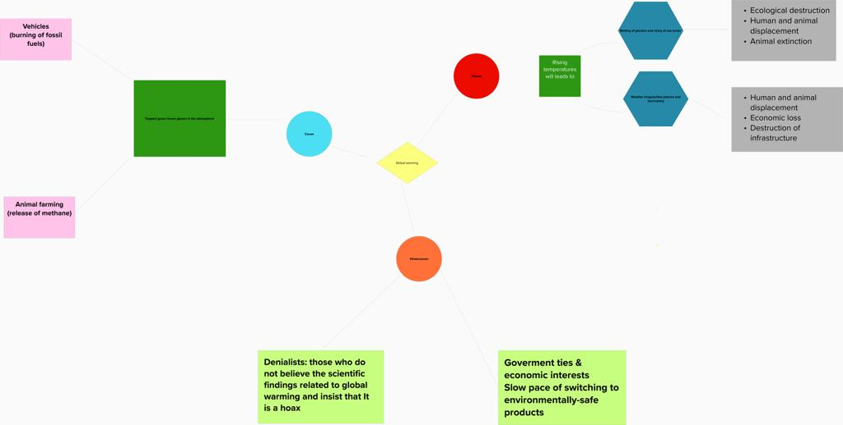

2.2 Ideation and Brainstorming map:

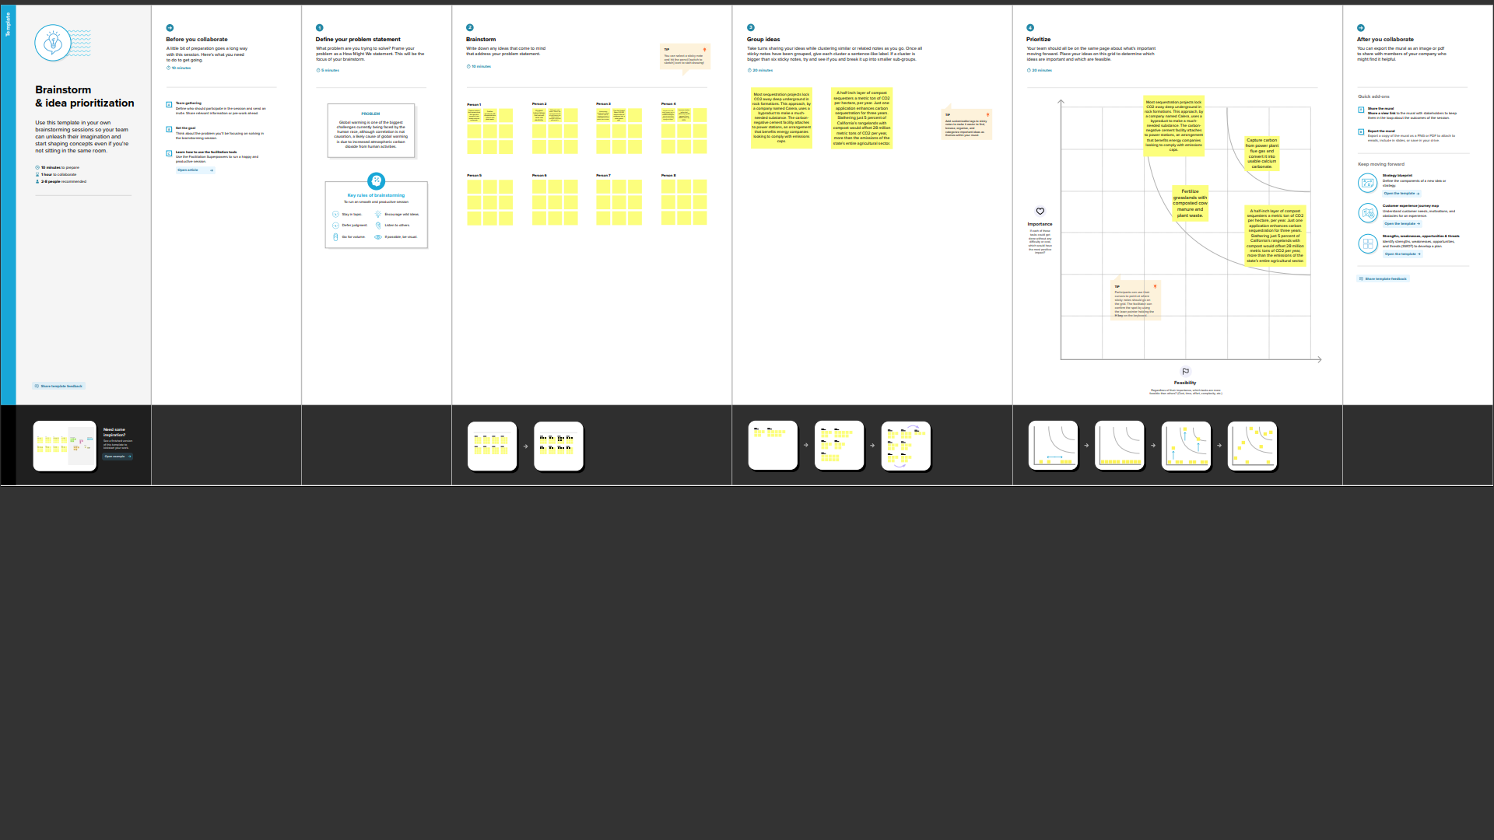

**3. Result:**

**Dashboard 1:**

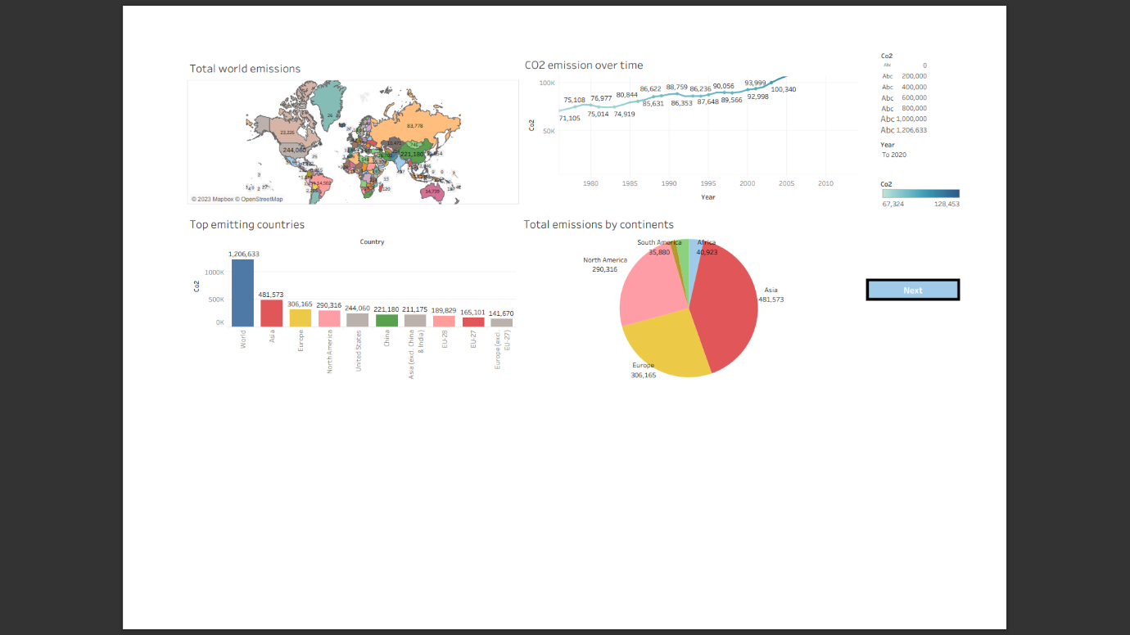

**Dashboard 2:**

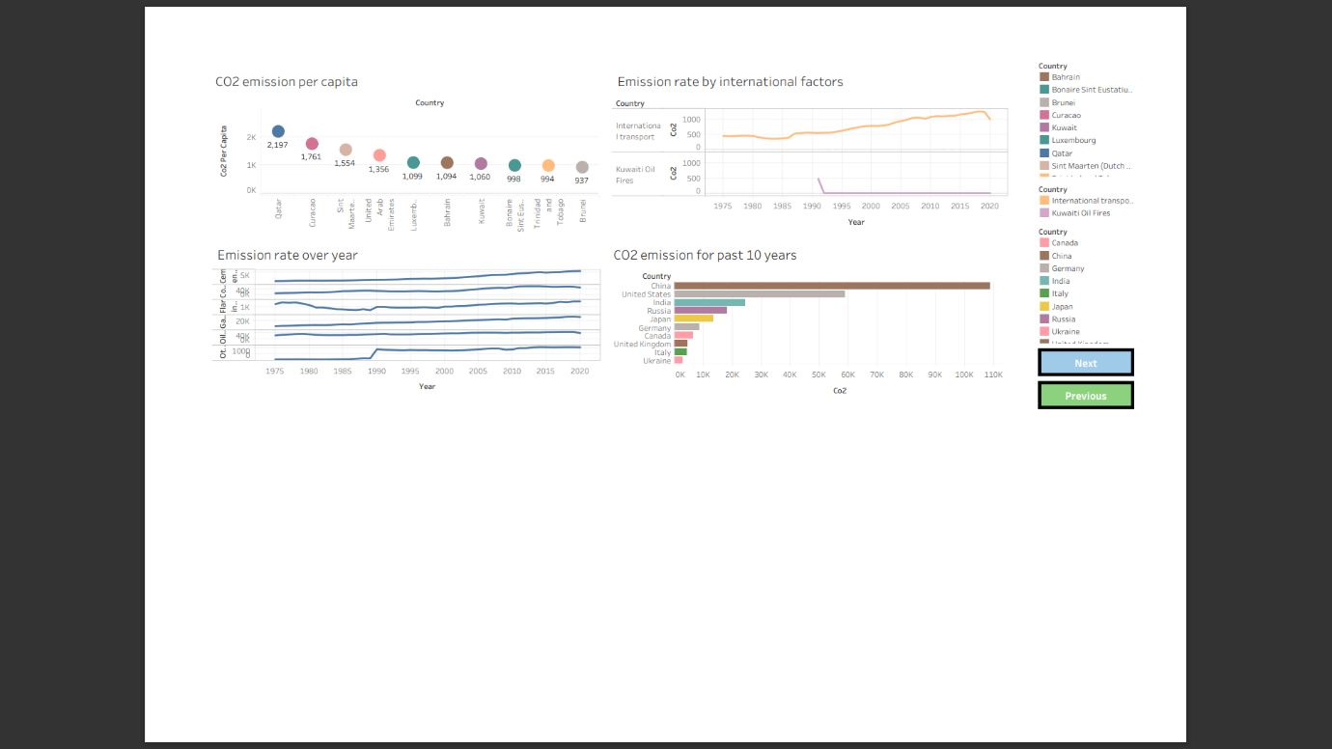

**Dashboard 3:**

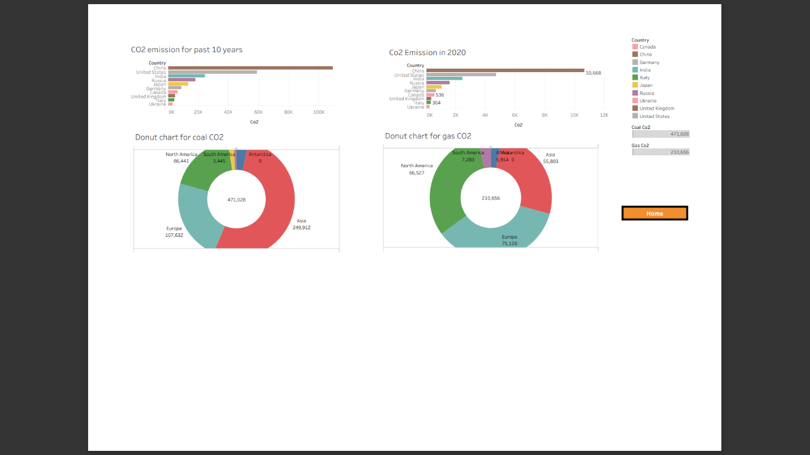

**Story:**

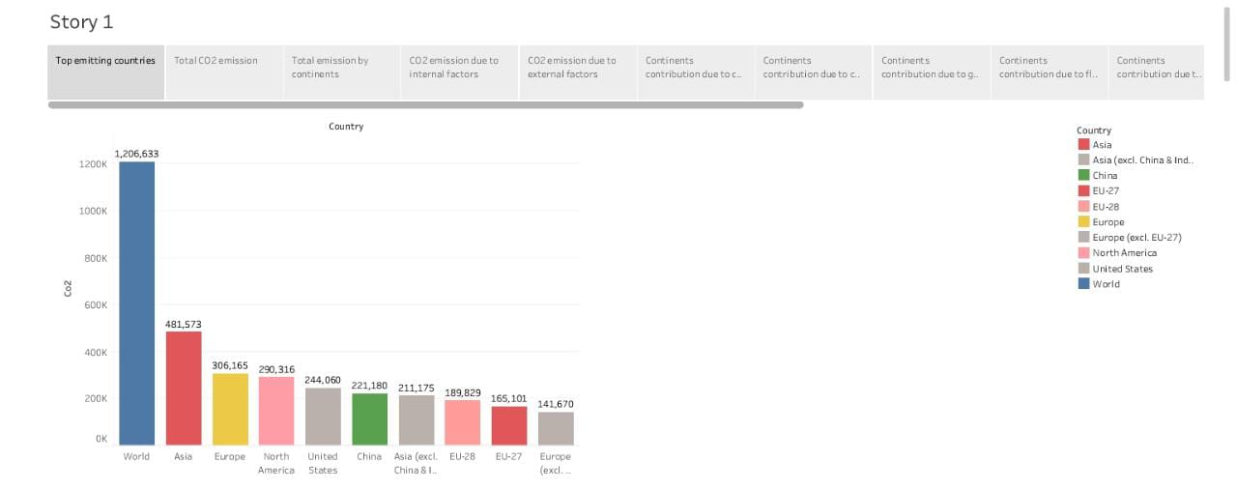

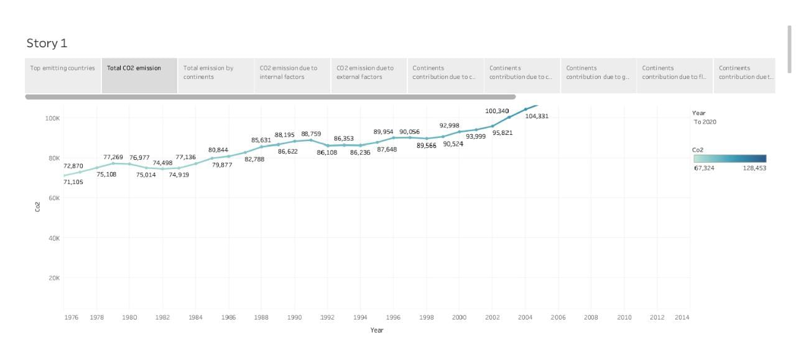

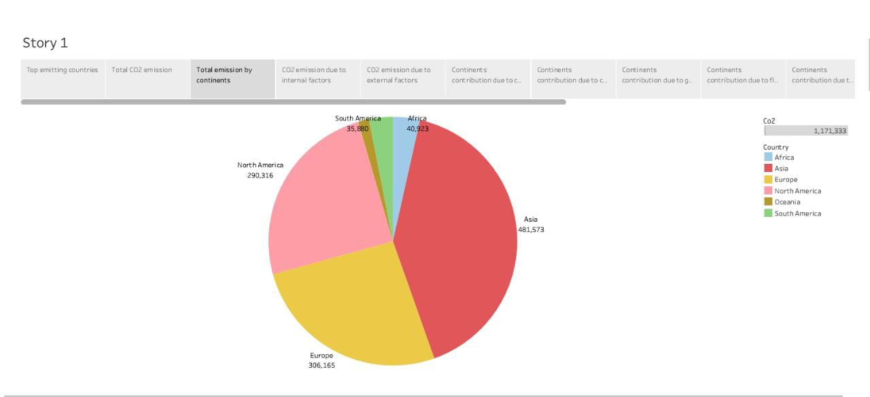

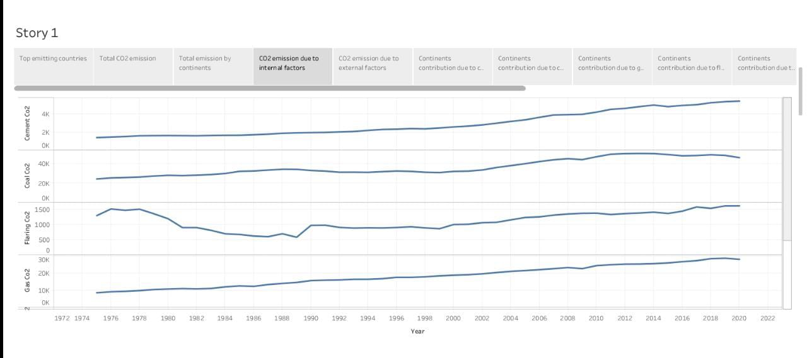

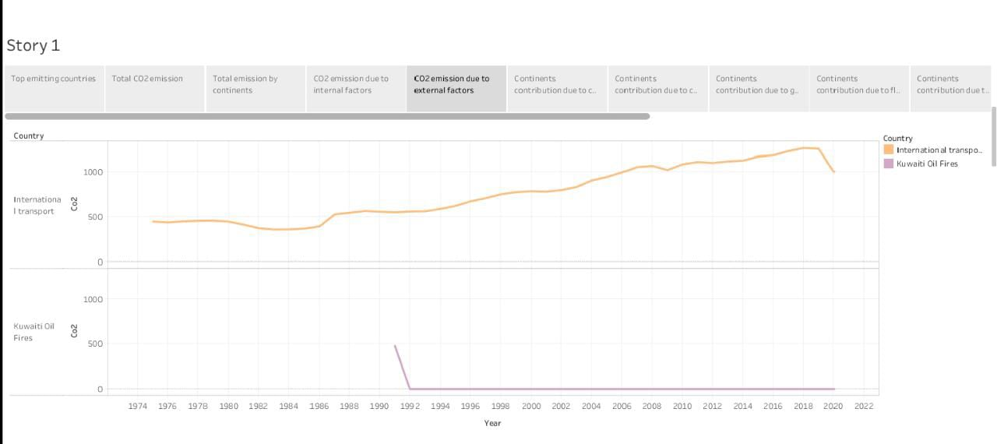

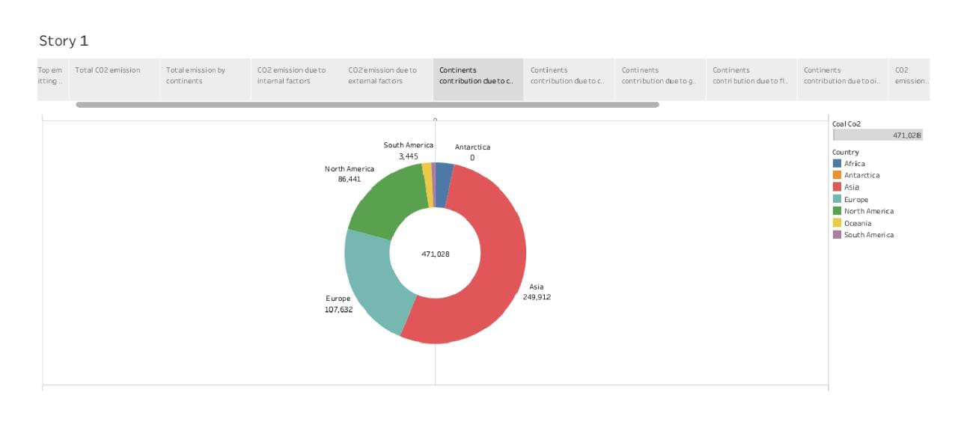

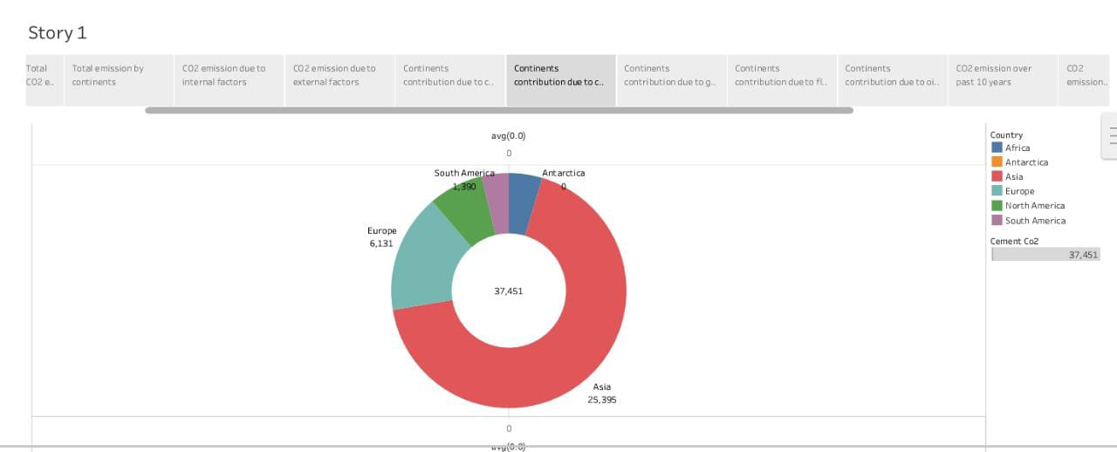

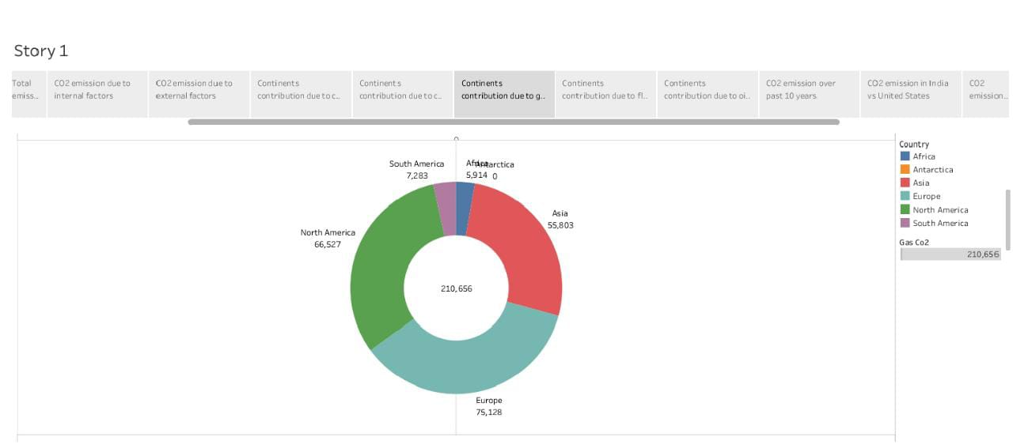

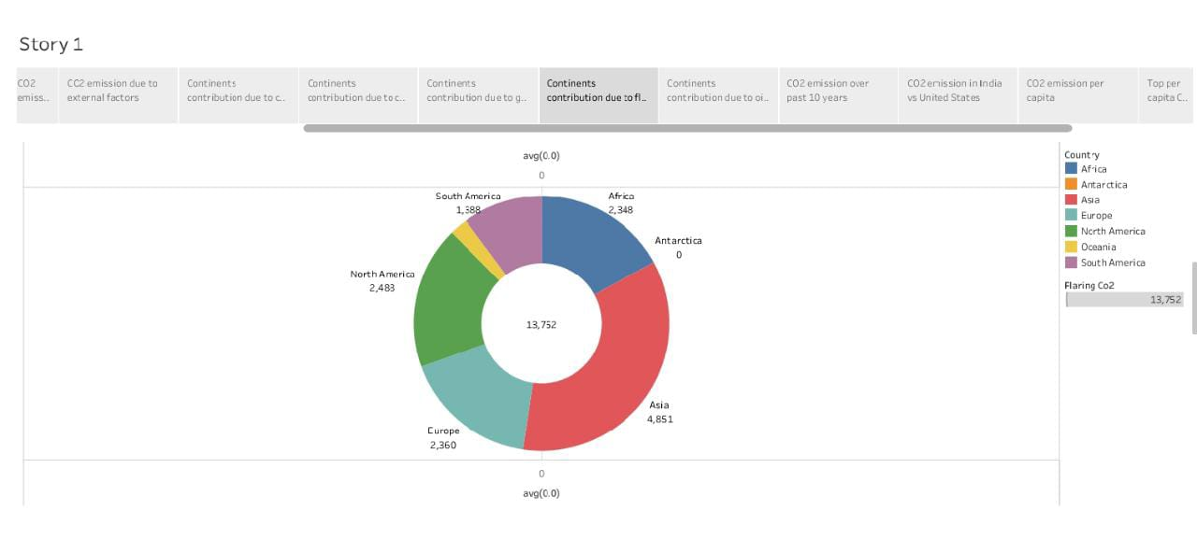

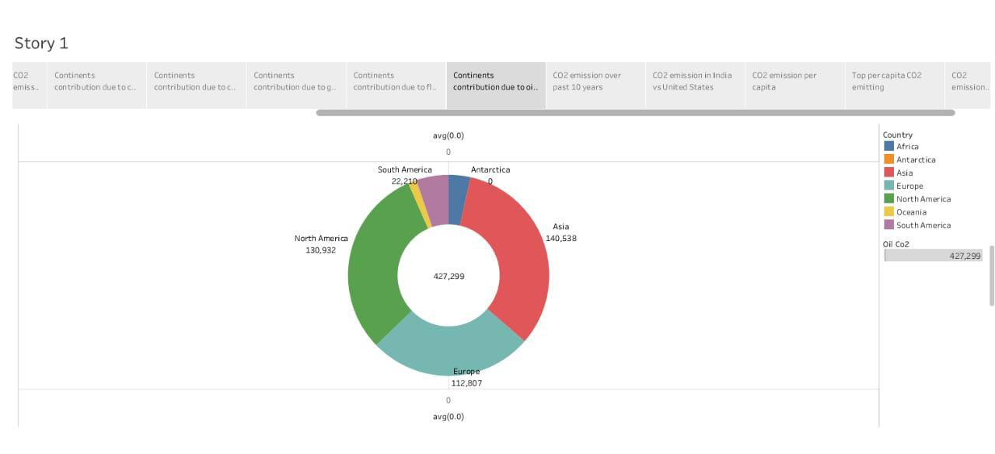

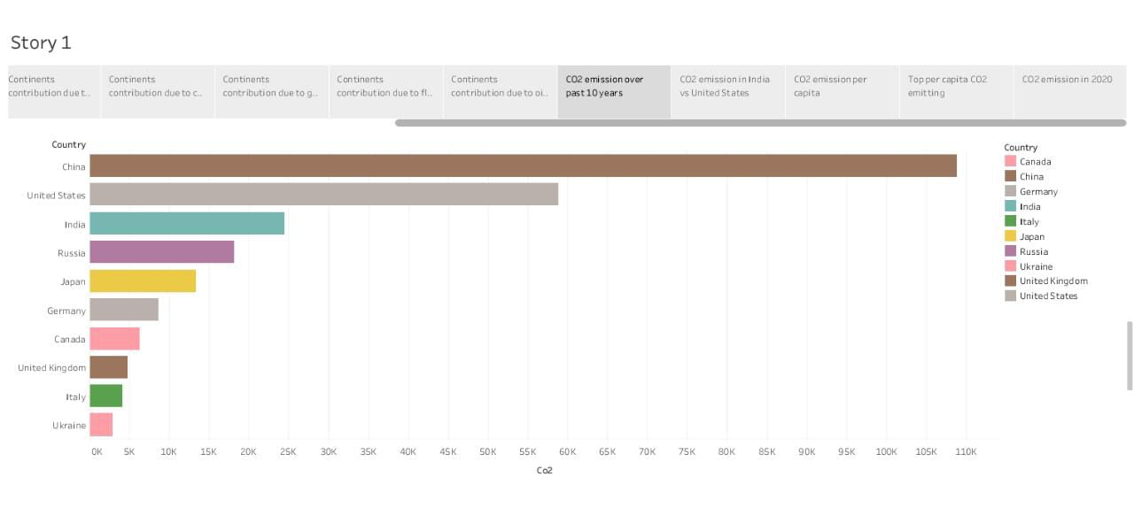

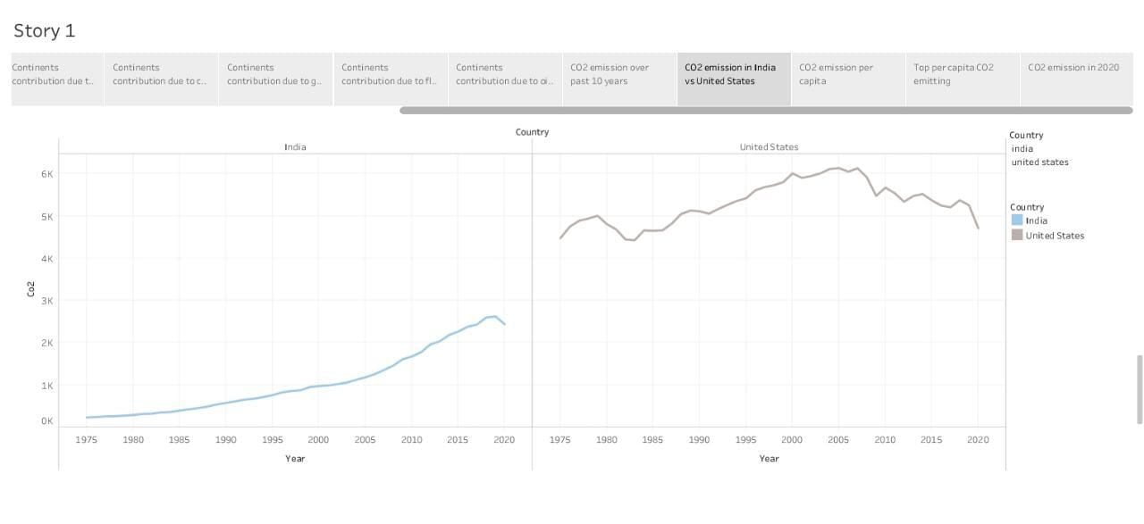

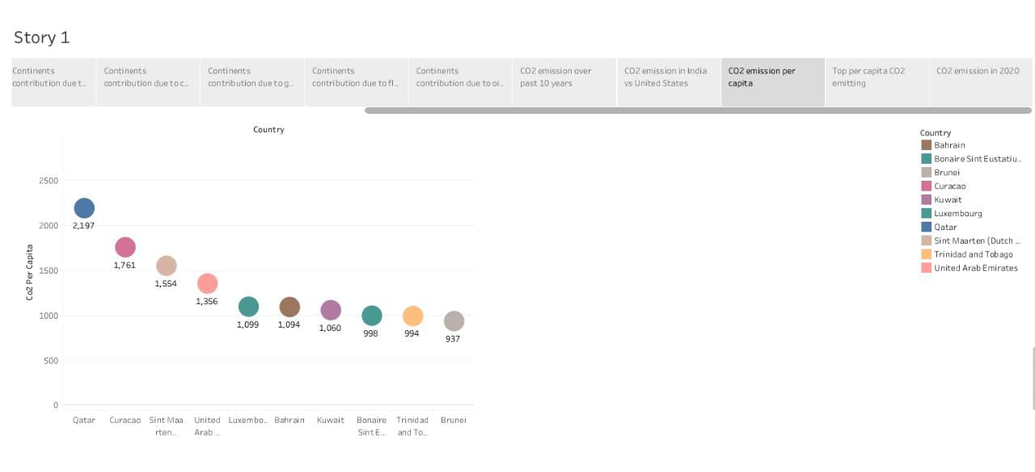

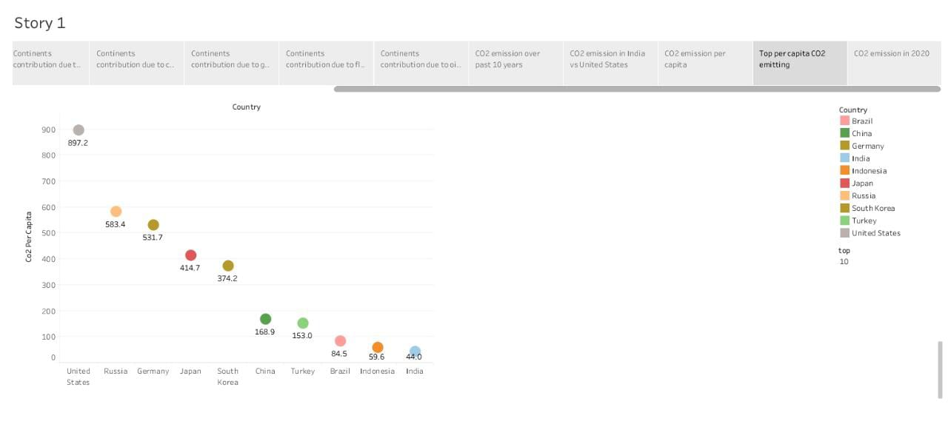

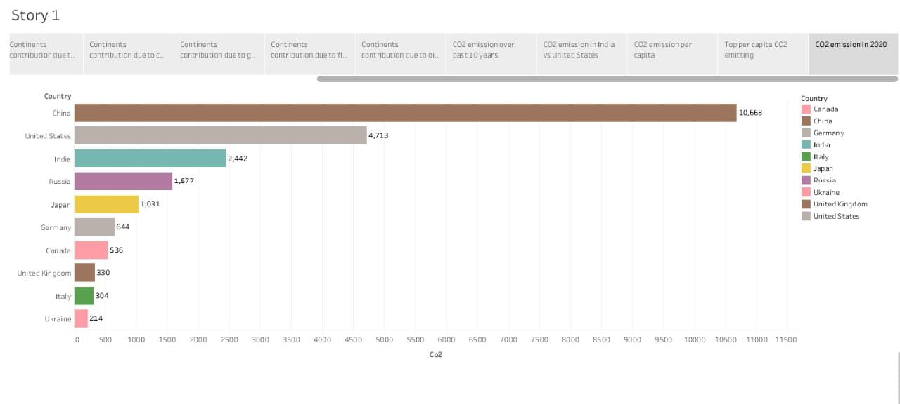

**4. Advantages and Disadvantages:**

Multiple accounting standards and varied implementations of net-zero accounting create room for manipulation, misrepresenting the pace of progress. For example, pledges that target only a subset of activities can make heavy-emitting industries appear to be net-zero and delay more transformative change. The verification of reported reductions and the execution of offset pledges represent an increasingly complex challenge, opening the scheme to manipulation. A single carbon offset can sit simultaneously on multiple entities’ balance sheets, inflating perceived impact. Nature-based offsets, such as afforestation schemes, take time to realise their impact. The short-term imbalances between when the offset is credited and when it yields its full benefit can lead to further climate detoeriation. Pledges made today for carbon neutrality at a future date are effectively commitments to buy offsets at an unspecified price. However, the price of carbon offsets will likely rise in the future due to constrained supply and increased demand. This may make planned offsets economically unrealistic and result in pledges not being fulfilled. Attempts to reduce emissions in one location may shift emissions to another where they are uncontrolled or uncounted. For example, a carbon offset programme that safeguards an area of rainforest in the Amazon from clear-cutting may result in the clear-cutting of an area of rainforest in the Congo Basin. Achieving a net-zero planet will require 100% of companies and countries to become net-zero. However, the elective basis of the net-zero will inevitably lead to partial participation. The biggest emitters are likely to have the most intractable challenges and the least incentive to commit. Most carbon offset solutions available today involve paying someone to not take an action (e.g. not to log a forest) which creates a financial incentive for offsetting entities to project anaction they had previously not intended to take and be paid for not taking it. Carbon offsets must be maintained through proper stewardship long after they are "bought" to sustain impact. For example, an acre of forest sold this year as a carbon offset may be destroyed next year due to neglect, fire, or even willful action on the part of the seller.

**5. Applications:**

Using CO2 in products or services does not necessarily reduce emissions. Quantifying the potential climate benefits is complex and challenging, requiring a life cycle approach. The climate benefits associated with CO2 use primarily arise from displacing a product or service with one that has higher life-cycle CO2 emissions, such as fossil-based fuels, chemicals or conventional building materials.

There are five key considerations in assessing the climate benefits of CO2 use:

1. The source of CO2 (from natural deposits, fossil fuels, biomass or the air).
2. The product or service the CO2-based product or service is displacing.
3. How much and what form of energy is used to convert the CO2.
4. How long the carbon is retained in the product.
5. The scale of the opportunity for CO2use.

Over time, and as fossil fuel use declines, the climate benefits associated with displacement will be reduced and the CO2 used must increasingly be sourced from biomass or through direct air capture (DAC). These CO2 sources can support a carbon-neutral life cycle for some CO2 use applications and could deliver negative emissions in applications where the carbon is permanently stored, such as in building materials (Figure 3). However, these negative emission opportunities are likely very limited and must be considered in the context of the product’s entire life cycle.

The carbon retention time for CO2 use applications can vary per product, ranging from less than one year for fuels, up to ten years for most chemical intermediates, to hundreds of years for polymers, while storage in building materials could last for millions of years. Critically, the potential of CO2 use to contribute to climate goals will depend on how far, and how fast, these opportunities can be scaled-up.

**6. Conclusion:**

The rising level of atmospheric CO2 could be the one global natural resource that is progressively increasing food production and total biological output, in a world of otherwise diminishing natural resources of land, water, energy, minerals, and fertilizer.

**7. Future scope:**

1. Stop buying your water in plastic. Get a reusable water bottle and keep it filled and with you at all times. You’ll save money and the environment!

2. Incorporate walking or biking to some of your regular short-trip destinations. In most instances, you can walk a mile in less than 20 minutes. This is a great way to add exercise to your busy schedule.

3. Turn off lights and unplug devices when you’re not using them. Every little action adds up.

4. Keep the tires on your car properly inflated and get regular tune-ups. When your car’s tires are low on pressure, it has to work harder to move from point A to point B, wasting gas and increasing emissions in the process.

5. Eat more food that is grown or made locally and less red meat. Taste the difference, feel better and support the Austin economy!

6. Use the cold water cycle for washing your clothes. And do your laundry in FULL loads. This will decrease the amount of water and energy used, helping you save time and money. Bonus points for line-drying – it takes a lot of energy to power your dryer!

7. Set your thermostat to 78 in summer and 67 in winter. And turn-off the heat and AC when you’re not home. You’ll be surprised at the difference it makes in your energy bill.

8. Drive efficiently. Use the accelerator lightly, coast to red lights, stay near the speed limit, and park and go inside instead of idling your engine in a drive-thru.

9. Keep stuff out of the landfill. Sell items you no longer use to thrift shops, have a yard sale, or donate them to charity. Recycle or repurpose everything you can’t get rid of.

10. Use alternative transportation (bus, train, carpool, or bike) to get to work one day per week. Enjoy the chance to catch up on your reading instead of testing your patience in traffic!

**8. Appendix:**

**Sourcecode:**

file:///C:/Users/MATHESWARAN/OneDrive/Documents/NAAN%20MUDHALVAN/Assets/index.html